Success stories

- Case Study no. : 01
- Title of story : Kitchen Garden
- Location : At- Bhemiya, Baniyakura, Katoria, Banka
- Project Facilitation Agency : Mukti Niketan Bhagalpur
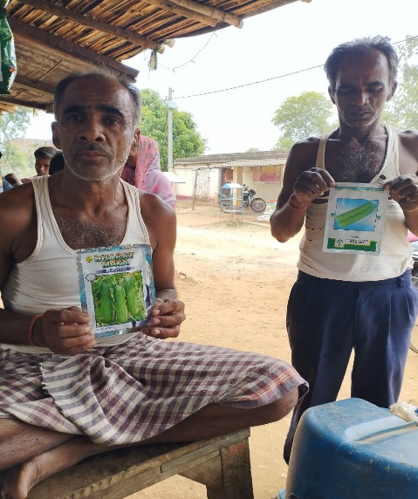
- Problem Description: Farmers can not buy green vegetables and their food content is not balance. This year there has been complete failure of monsoon. The farmer has gone to hand to month.

- Initiation taken- Under Kitchen Garden Scheme Mohan Yadav was selected. He promised to follow all norms. He bounded the area, ploughed properly, removed weeds, put compost in the soil and sowed the seeds. Proper care was given on dressing and irrigating. Plants grew well flowering and fruiting resulted in time.

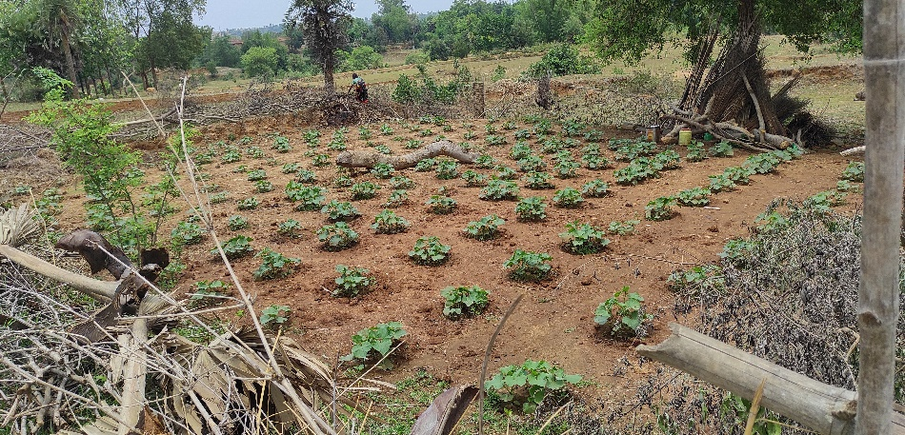
- Progress & Result- Fruiting was very nice, everywhere in and around the villages there was shortage of green vegetable consumes like local vegetables. They organic products. Mohan was encouraged. He did not loose patience. He started selling vegetables. Quality was very good. Fresh Vegetables Were appreciated everywhere. He spent his bad days and he is happy to enjoy the fruit of labour.

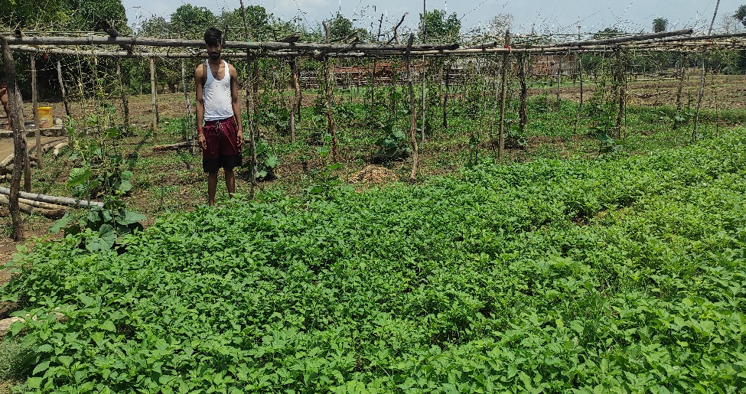
- Impact: The dire necessity of the family, for a shot period, could be et up with selling of vegetables people appreciated and he feels satisfied.

- Inspiration - Land gives $≠$ life and livelihood.
Labour never goes in vain.

- Case Study no. : 02
- Title of story : Integrated Farming
- Location : At- Dumardiha, Maheshmara, Katoria, Banka
- Project Facilitation Agency : Mukti Niketan Bhagalpur

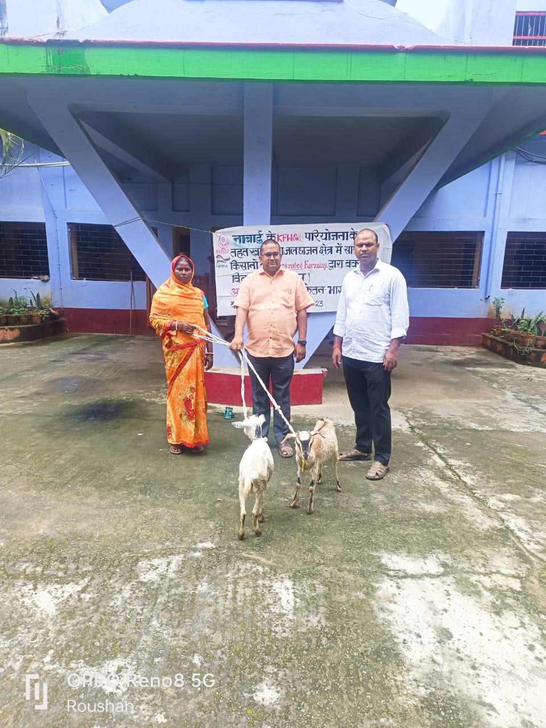
- Problem Description: Mrs Lilawati Devi Is an uneducated woman aged 42 years with 16 years of farming experience. She used to grow traditional crops on her farm with average yields of various crops and animal enterprises before coming in contact with Extension functionaries of Mukti Niketan and NABARD. She mostly used chemical fertilizers in her farms. Due to which the crop yield was not good.

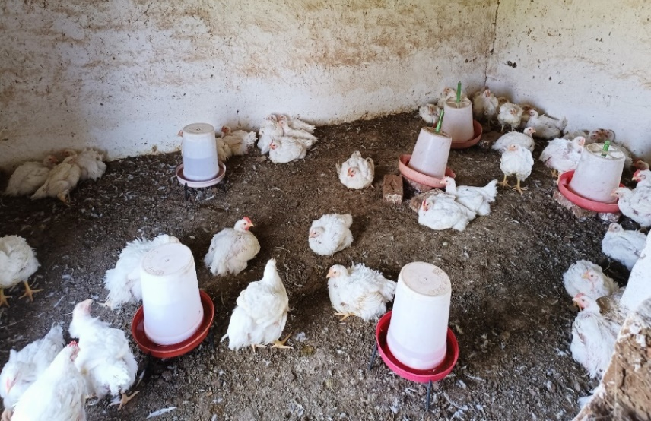
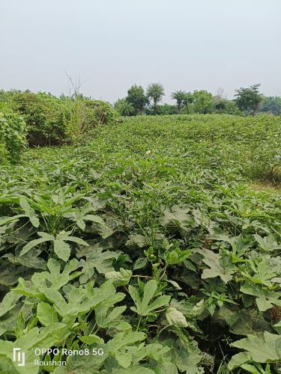
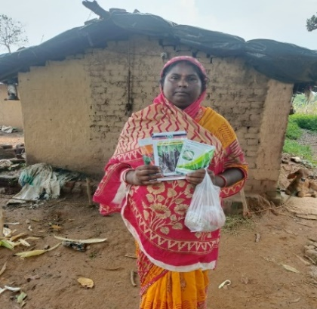
- Initiation taken- Under integrated farming in KfW soil project Smt. Lilawati Devi was selected. She promised to follow all norms. She bounded the area. Under this scheme Mukti Niketan provides her poultry, goats, created a kitchen garden, provides fruit plants and also provides some seeds for integrated farming. Thereafter, she was exposed to the latest improved new technical knowledge of agriculture and her attitude changed towards agriculture and she was motivated to take agriculture as agri-business with adoption of all latest technologies for improving production and productivity of her farm. She attended various training programmes at Mukti Niketan under KfW soil project and experts from NABARD. She is starting use of vermi compost, vermi wash in Crop production, Bamboo stalking in cucurbit crops and growing of high yielding fodder varieties.

- Progress & Result- Along with using improved varieties she also practices seed treatment followed by treatment with bio fertilizers and resource conservation technologies for getting high returns and reducing the cost of cultivation.

Success in an integrated farming system with milk from a dairy unit, use of vermi compost, vermi wash in Crop production, Bamboo stalking in cucurbit crops and growing high yielding fodder varieties.

- Impact: Keeping in view of water scarcity she switched over to kharif Maize cultivation in replace of rice crop in some area
In view of changing climatic scenario and excess use of chemical fertilizers and pesticides in crops, she shifted to organic farming two years back and received technical guidance from Mukti Niketan under KfW soil project from NABARD.

By all these crop and livestock enterprises she is earning a handsome net income of Rs. 3.7 lakhs per annum.

- Inspiration - She is recognized as a progressive Farm woman & Master Trainer for farmers in the district & women are following her steps

